Objective: Manas, your video was superb, where you demonstrated the ingestion and extraction of raw content from files users typically save on their local devices. Very impressive, sir! Now that we have the raw text, the next step will be to preprocess the text such that you can store cleaned, normalized texts into tokens. Thus, this week’s litmus test is to show we can preprocess and tokenize the texts in users’ files.
Because content extracting, cleaning, and labeling are tasks within the preprocessing of the data, we will attempt to complete three stages as part of this week’s overall objective.
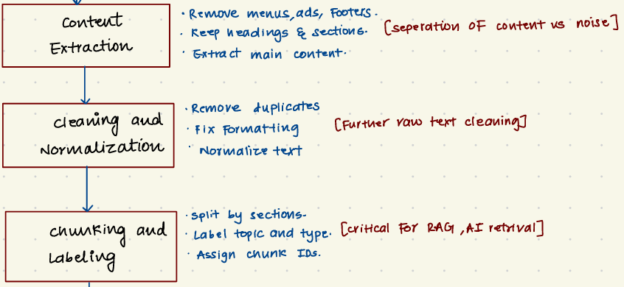
The guidance you provided in Week 3 remains applicable this week:
At a high level, the diagram illustrates the following flow:
A user provides input in the form of a website URL, PDF, document, or text. The tool first validates the input and then collects the source content. This content is extracted and cleaned to remove noise such as navigation elements, ads, or duplicated text.

The extracted content we stored from the files in Week 3, we now want to tokenize/split cleaned, normalized texts into chunks. We will store these tokens for use in Week 5’s task, which will be to create the JSON-LD schemas, apply prebuilt transformers, and generate the output we will load into AnythingLLM (or similar).
Deliverables: By Saturday, 2/07/2026, please email the following:
- Video demonstration of the source code that preprocesses the stored, extracted raw data and tokenizes/split the data into machine accessible chunks. (I may be using tokenizing and chunking interchangeably. Ultimately, we will want to parse the cleaned texts into manageable tokens or chunks readable by RAGs or LLMs. I am open to your expert recommendation). The chunk IDs showed by stored in a way that they can be used in the next steps in our flow diagram (i.e., Week 5 = metadata & schema, artifact packaging, and reuse).
Instructions: The guidance I have provided is at an extremely high level. You are the technical expert on this team. I am providing the weekly milestones for my own edification, such that I can pitch this idea to my business school colleagues in a way that is inclusive and accessible to them. We are not as technically astute as you, so my aim is to explain to them the following steps we have taken to move from local files on a computer to a RAG-accessible model that can be loaded into local LLM tool, such as AnythingLLM, LM Studio, or Ollama. Here is my logic:
- User input and extraction: Users upload the files they wish to make accessible into a RAG or LLM (similar to NotebookLM). Content are stored as raw text (as demonstrated in Week 3’s video).
- Preprocessing user content: User’s stored content is preprocessed, tokenized/chunked, and stored as vector embeddings (forthcoming Week 4 video demonstration).
- Artifact packaging: Vector embeddings of user’s content are bundled and mapped to JSON-LD schemas and made accessible for use in a RAG or LocalLLM (Week 5 video demonstration) .
If this logic is faulty, please feel free to provide corrections. I may have an opportunity in February to pitch theLLMStore idea to Kelley faculty for (1) feedback on grant writing or (2) direct Kelley School funding.
I appreciate everything, sir, and look forward to your amazing work!
Have a great weekend and week ahead, Manas.
Respectfully,
Nick

